**Wireframe Document**

**Entertainer Data Analysis**



Table of Contents

Information: 3

Homepage 4

Entertainer Analysis Page 5

Movie tool tip 6

Movie analysis Page 6

Top 5 actors/ actress 7

Movie List 8

Movie count Trend 8

Rating trend 9

Information Page 9

# Information:

I have populated required data for all the entertainers and then created PowerBi report,



# Homepage

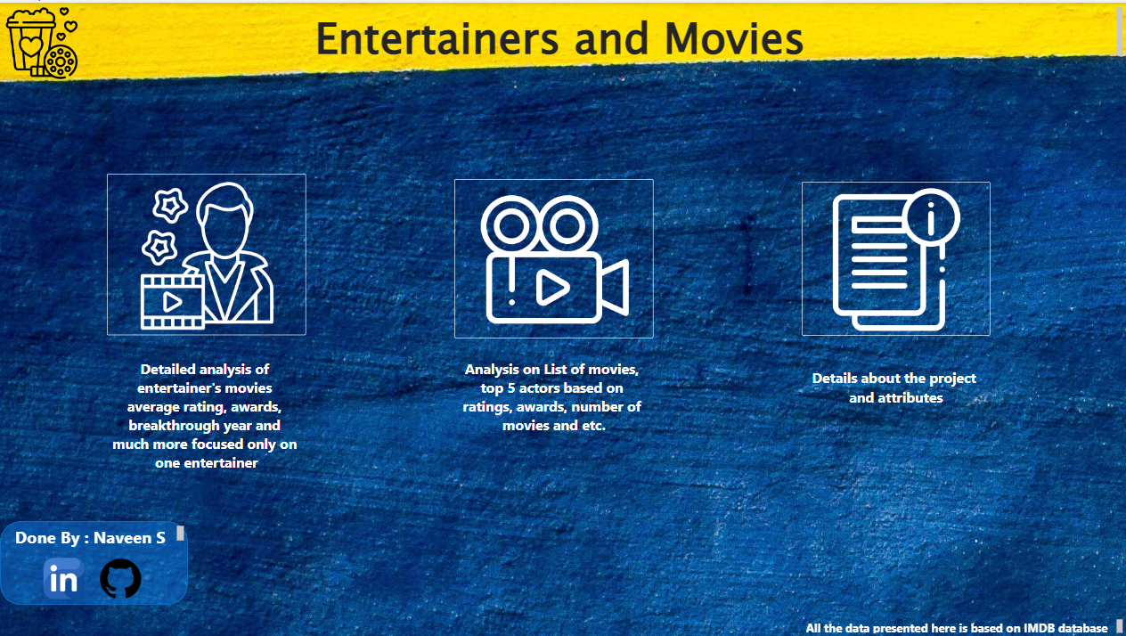

As per the requirement of the project, I have divided the analysis into two sections

* Entertainer focused analysis
* Overall movie and entertainer analysis

Homepage will have the button to navigate to the following pages,

* Entertainers Analysis
* Movie Analysis
* Information page of the project

# Entertainer Analysis Page

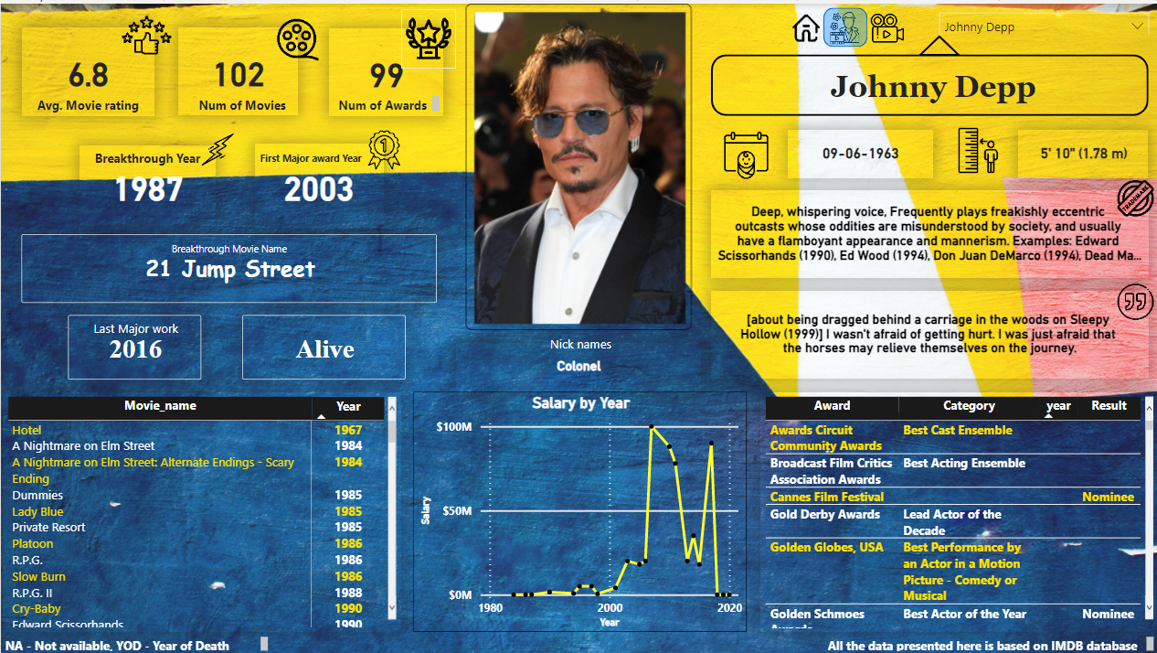

This page mainly focuses on the induvial entertainer, KPI list as follows

* Average Movie rating
* Number of Movies
* Number of awards
* Breakthrough Year
* First Major Award year
* Breakthrough Movie name
* Alive/YOD
* List of movies and years
* Salary by year
* DOB
* Height
* Trademarks
* Quote
* Awards and category
* Headshot of the entertainer

### Movie tool tip

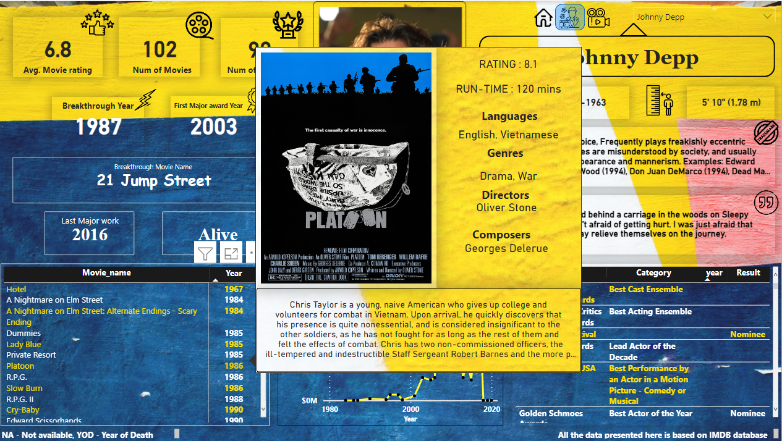

By hovering the movie name, the user can get to know the movie details with the pop up.

# Movie analysis Page

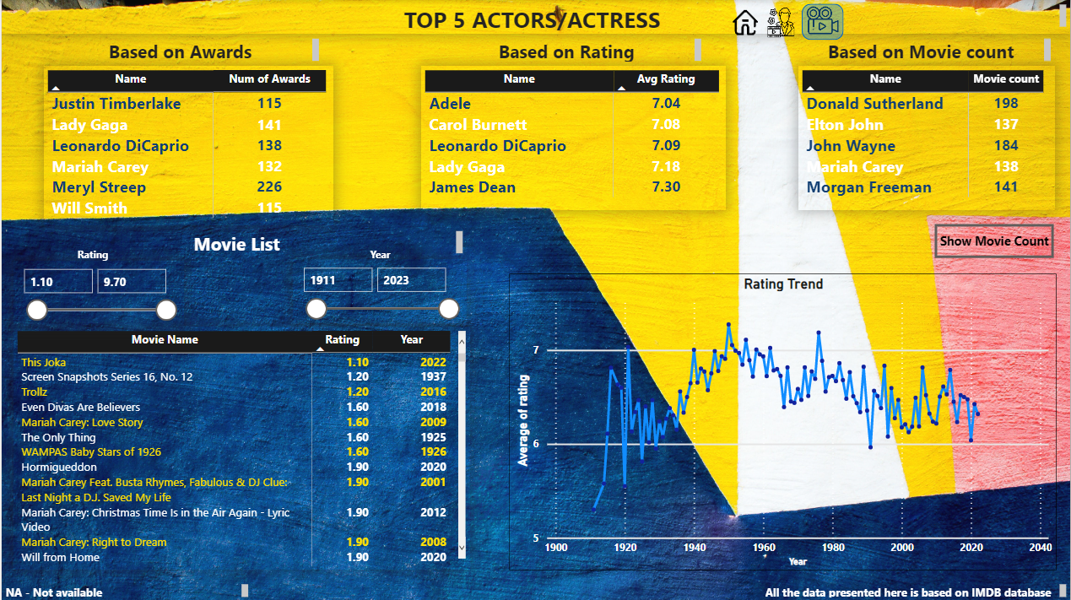

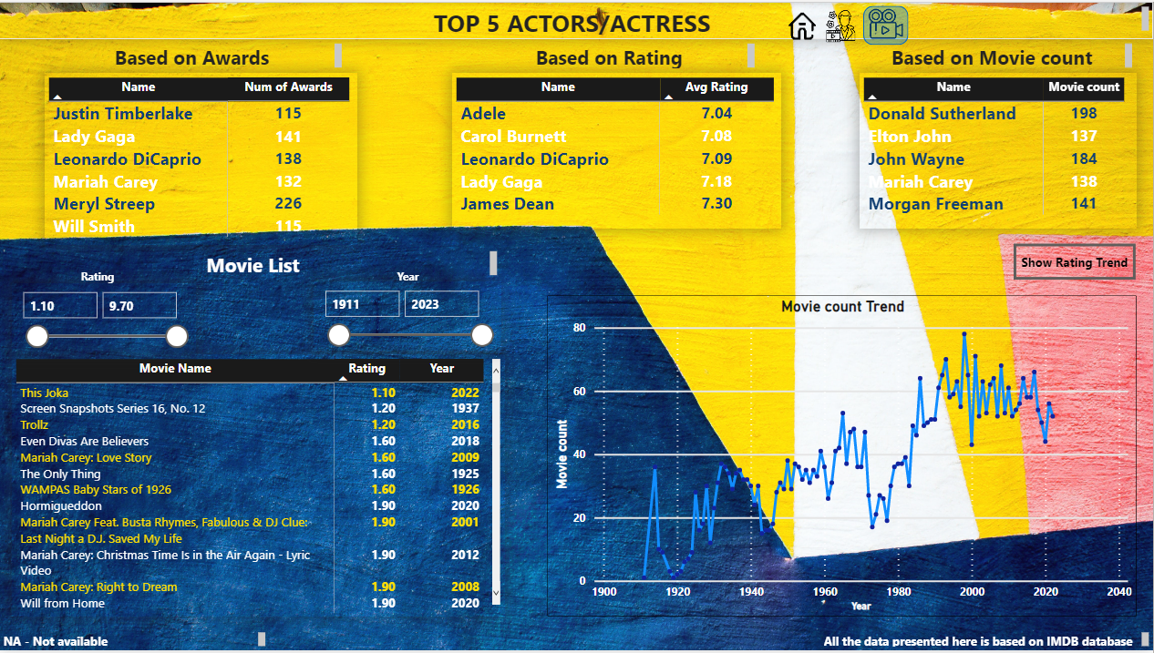

### Top 5 actors/ actress

* Based on number of Awards
* Based on average rating
* Based on Number of movies

Were displayed in the table form.

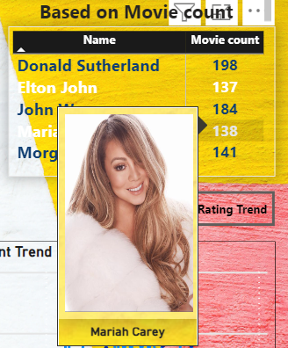

### 

By hovering on the entertainer’s name, user can see the entertainer’s photo which will be showed in pop up

### Movie List

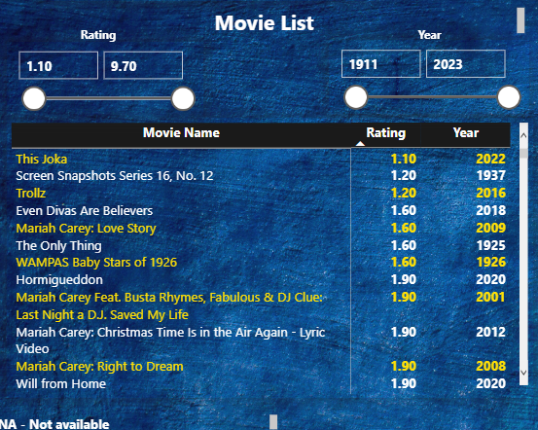

Movie list with two filter has been added to the report, user can change the filters according to the need, and get the list of movies.

### Movie count Trend

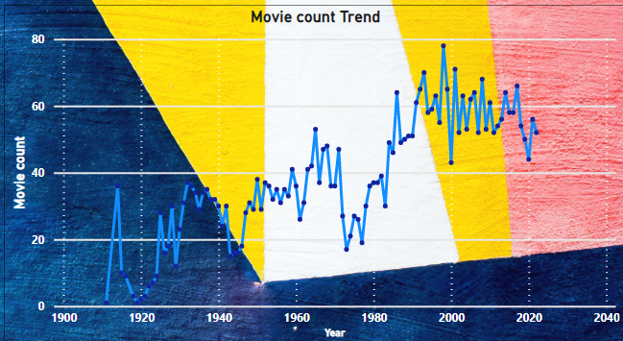

It will represent the trend of movies count over the years.

**1998** – registered high number of movie release which is **65** by the list of entertainers

**2022** – registered as of now, **55** movies

### Rating trend

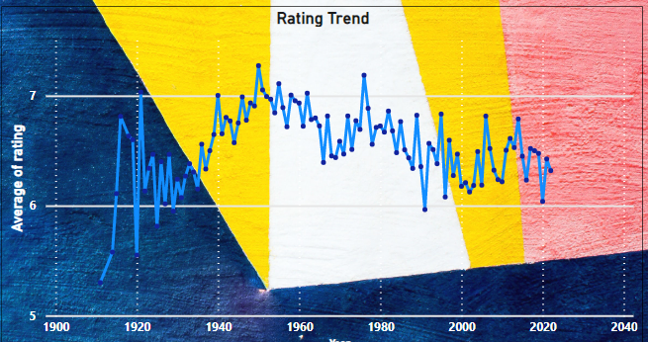

This graph represents the average rating trend of the movies

1950 – registered the high rating among all the years, which is 7.27

2022 – registered 6.32 as of now

# Information Page

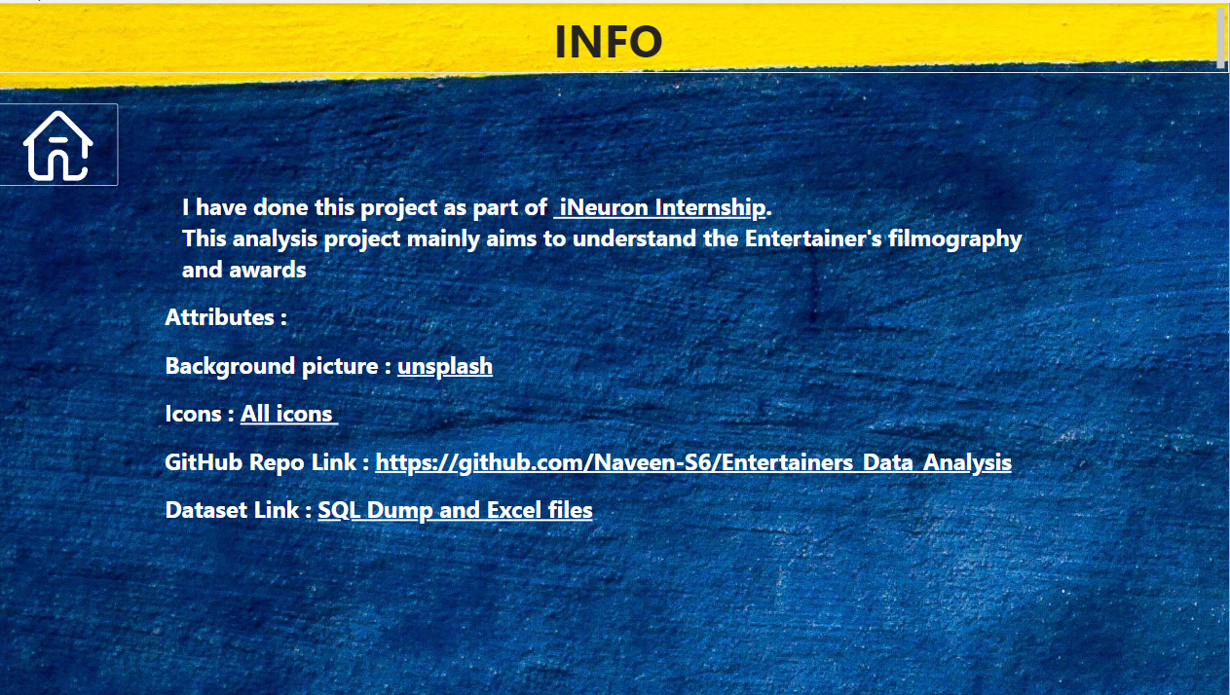

This page will include all the project details and dataset, GitHub repo links